**Creating immersion for our project**

For our project, keeping the player engaged is the top priority. We have already twisted their expectations of the genre by altering the mechanics, and now that they trust us with their time to play our game it is imperative that they *enjoy* their time with the game so that they get a feeling of satisfaction once they are done.

Immersion isn’t just keeping the player engaged, however; it’s also a matter of making them feel like they are not just a bystander in the events of the game but an active part of them. A simple solution to this is to create context for what is happening in the game. As our game is a 2D platformer, it would not fit to create an intricate and dialogue-heavy story to explain what is going on. “Newtonian engagement” is key; the player should always feel like they are progressing and doing something meaningful within the game, and the less barriers we put between the player and this engagement the more successful our game will be.

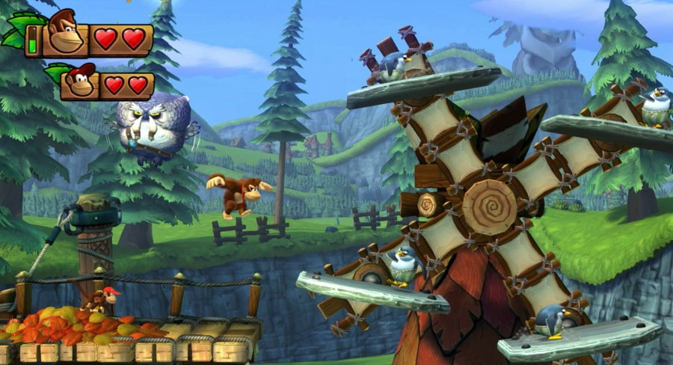*“Donkey Kong Country: Tropical Freeze”* is a primary example of how we could create context with no dialogue. As Figure 1 demonstrates, the platforms are all part of the surrounding environment, for example, the sails on the windmill in the background have platforms on them that rotate, which make them feel more organic and a part of the game’s world, instead of the typical *Super Mario* fare of having blocks and objects floating in the sky for seemingly no reason.

Figure : Context has been created by making the platforms sails on a windmill.

Levels in *Tropical Freeze* also tend to follow a ‘narrative’ in acts as the player progresses through the level. For example, one level takes place underwater, and begins with the player waking up a giant octopus. Said octopus then goes on a rampage, smashing up ships in the water, which act as the platforming challenges for the second section of the stage. The final section is a chase sequence in which the player must escape the octopus until it hits its head on a rock wall and is defeated.

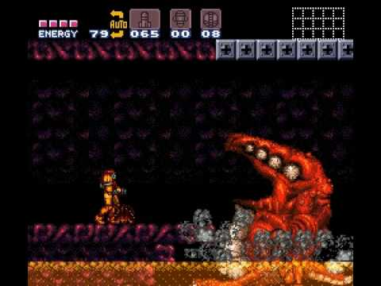Depending on how our levels are structured (as unique instances with a level select menu in between or as one large continuous level) this type of narrative level design could work. However, another (and arguably more fitting) example is *“Super Metroid*”, as that contains both this type of narrative level design while having one large, continuous map split in several interconnected sub-areas.

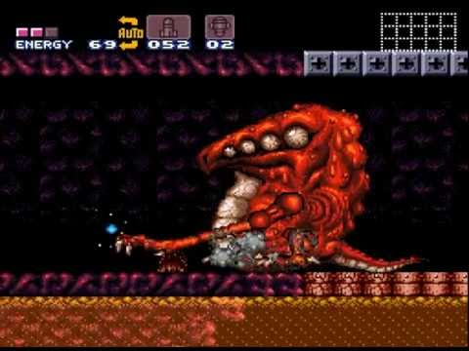

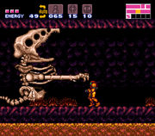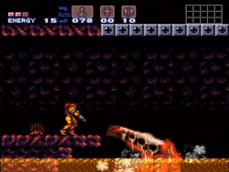

Figure : Crocomire meets a grisly end at the hands of the player.

In one of these areas, Norfair, the player encounters a boss named “Crocomire” that they must defeated by forcing it backwards with missiles until it walks over a weak area of land and drops into the lava below. The player is then treated to seeing Crocomire flail around in pain in the lava as its skin melts off. There is no away to cross the lava, as the player has no grapple beam at this point, so they must backtrack to the other end of the corridor, where Crocomire’s skeleton smashes through the wall and collapses, allowing the player to get the items behind the wall and escape the boss arena. What makes the fight worse, however, is that Crocomire only attacks the player if the player shoots first, so effectively the player brutally kills what is an innocent animal that was trapped in an area outside of its habitat by the main villains of the game-the Space Pirates. This reinforces the players want to defeat the Space Pirates while also demonstrating that Norfair is the penultimate area of the game and thus the player should be ready for extremely brutal and gruelling challenges before they can face the final boss; as such it is a perfect example of non-verbal level design and immersion, and I could implement similar ideas into my level design (though obviously not on the same scale as there are limitations).

To summarise, making the player feel as though they have been dropped into the game world and want to explore is a primary objective for the sprints going forward, breaking this immersive bubble can make the player feel as though their time is being wasted. By creating a level layout that encourages exploration as well as events in the levels that keep the player engaged and non-verbally communicate to the player what to expect in the game world, I can keep their attention focused on the game, so that they feel their time has not been wasted by playing the game.